Coral S. Schmidt Montilla #148830

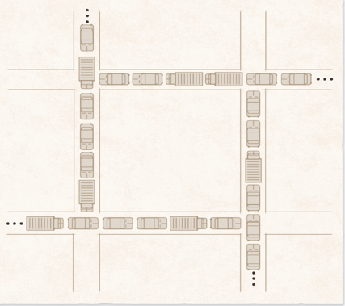

Figure 7.1. Traffic deadlock example (Deitel, H. M, Deitel, P. J., and Choffnes, D. R. (2004a))

1. State the four necessary conditions for a deadlock to exist. Give a brief intuitive argument for the necessity of each individual condition.
   1. Mutual Exclusion: This condition arises because specific resources cannot be simultaneously shared between multiple processes. Imagine a scenario where a resource, such as a printer, can only be used one process at a time. If one process controls the printer, others must wait, potentially leading to a deadlock as each process holds a resource while waiting for another.
   2. Hold and Wait: This condition adds a layer of complexity to the deadlock situation. Here, a process holds onto a resource while simultaneously waiting to acquire additional resources. For instance, consider a process that has acquired a printer but also needs access to a scanner. While holding the printer, it waits indefinitely for the scanner, preventing other processes from using the scanner and potentially leading to a deadlock.
   3. No Preemption: Once a process holds a resource, it cannot be forcibly removed. If a process has control over a resource and needs additional resources to proceed, it cannot be preempted to release the held resource. This lack of preemption can contribute to a deadlock as processes hold resources indefinitely, waiting for others to release what they need.
   4. Circular Wait: This condition occurs when processes form a circular chain, with each process holding a resource that the following process needs. For example, Process A holds Resource 1 and waits for Resource 2, Process B holds Resource 2 and waits for Resource 3, and so on until Process N holds Resource 1, creating a circular dependency that results in a deadlock.
2. In the context of traffic deadlock (see the figure below), discuss each of the necessary conditions for deadlock
   1. Mutual Exclusion: In traffic deadlock, mutual exclusion occurs because specific resources, such as roads or intersections, can only be accessed by one vehicle at a time. This limitation leads to traffic congestion and potential deadlock situations, as vehicles must wait for others to clear the resource before proceeding.
   2. Hold and Wait: Vehicles in a traffic deadlock scenario often exemplify the hold and wait condition. A vehicle may hold its position at an intersection while simultaneously waiting for other vehicles to clear the way, leading to a standstill as each vehicle holds its position while waiting for others to move.
   3. No Preemption: This condition underscores the potential severity of a deadlock situation. Once a vehicle occupies a position on the road, it cannot be forcibly moved aside by another vehicle. This lack of preemption contributes to deadlock situations as vehicles may block each other's paths and be unable to proceed until the deadlock is resolved by external intervention or one or more vehicles reverse their positions.
   4. Circular Wait: In traffic deadlock, circular wait occurs when vehicles form a circular chain, each blocking the path of the next. For instance, Vehicle A may be waiting for Vehicle B to move, while Vehicle B is waiting for Vehicle C, and so on, until a cycle is formed, preventing any vehicle from progressing and resulting in a deadlock scenario.